**ETL Project - Cryptocurrency**

# Objective:

* To Extract, Transform and Load of cryptocurrency historical prices from different source system
* To use pandas data reader to retrieve up-to-date data from Yahoo Finance and SP500(Fred)
* To analyze cryptocurrency and SP500 correlation thru ETL process

# Data Sources:

* Kaggle: <https://www.kaggle.com>
  + https://www.kaggle.com/sudalairajkumar/cryptocurrencypricehistory
* Yahoo: [https://finance.yahoo.com](https://finance.yahoo.com/topic/crypto/)
* https://fred.stlouisfed.org/series/SP500

# Extract:

* To generate Jupyter notebook (Pandas) for reading csv files and retrieving data from yahoo and SP500 for up to date data.
* Based on the cryptocurrency historical dataset, we select the 10 cryptocurrency data in conjunction with the updated data retrieved from yahoo and SP500.
* To use web scraping to retrieve cryptocurrency data and SP500:
  + ADA - Cardano
  + BNB - Binance
  + BTC - Bitcoin
  + DOGE - Dogecoin
  + DOT - Polkadot
  + ETH - Ethereum
  + UNI - Uniswap
  + USDC - USDCoin
  + USDT - Tether
  + XRP - XRP
  + SP500
* **Extract data from Yahoo Finance**

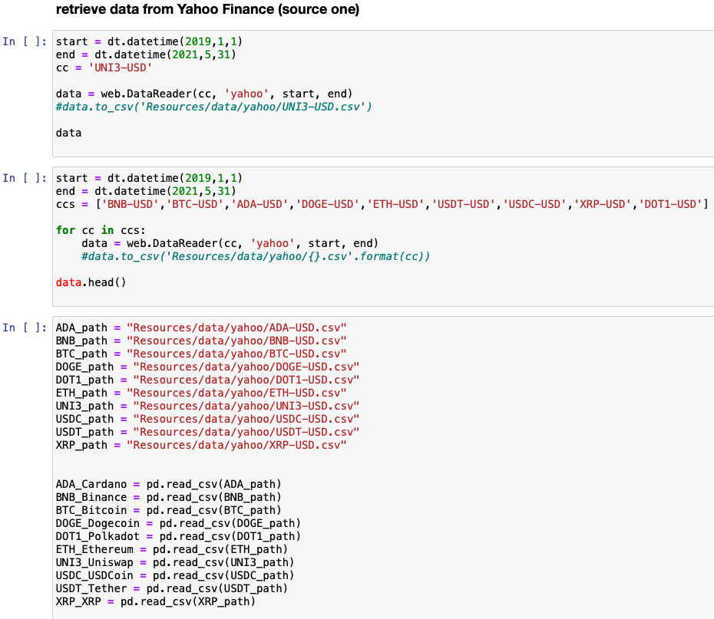

* **Extract data from SP500 (Fred)**

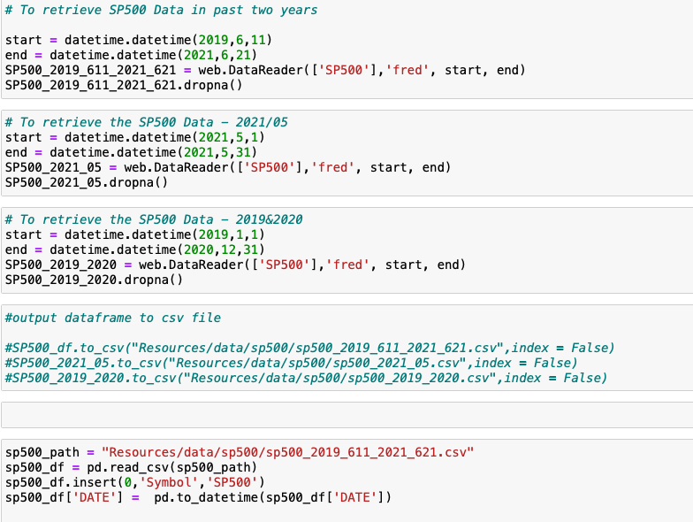

# Transform:

* Pandas DataFrames used to load the CSVs generated via web scraping and downloads.
* Files were reviewed and cleaned before being uploaded to SQL via SQLAlchemy.
  + symbol: UNI3-USD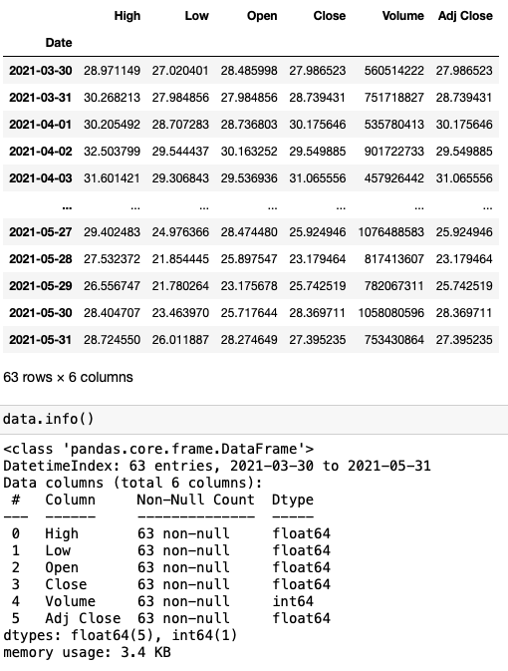
* Add the symbol to DataFrame

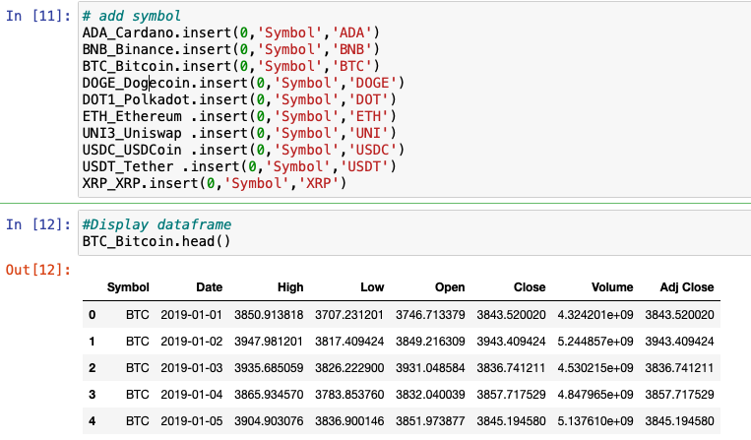

# Load:

* SQLAlchemy was used to load the files into the SQL databases.
* The attached schema was used to prepare our extracted/transformed files and their respective tables into PostgreSQL .
* PostgreSQL Database & Schema 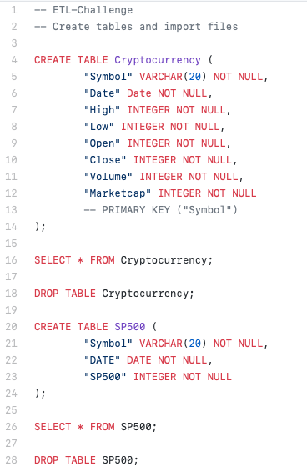
* To connect local database

